**Texas A&M University-Commerce**

**Ticketrak Refund Process**

# STEP 01:

Go to Ticketrak Portal and Login with **SSO**:

**URL:** [Ticketrak](https://ctitt-tamuc.cticloudhost.com:8082/)

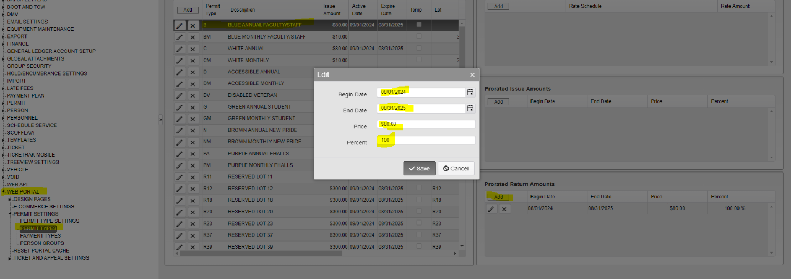**ADMIN > SYSTEM SETTINGS > PERMIT SETTINGS > WEB PORTAL > PERMIT TYPES**

**In the permit type, select the permit you want to refund. When you select the permit type example, BLUE ANNUAL FACULTY STAFF**

* CLICK ON THE **BLUE ANNUAL FACULTY STAFF PERMIT** in the **middle box**
* Click on the **ADD** button in the **PRORATED RETURN AMOUNT** box
* Fill the date range **August 01, 2024** to **August 31, 2025** (FY 24-25)
* Percent is always **100.00** unless there is a partial refund.
* SAVE and exit out.

# STEP 02:

* 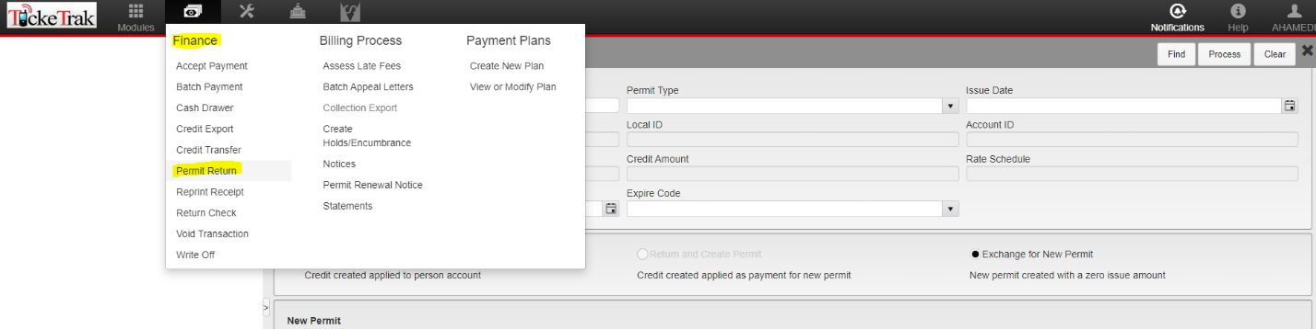Go to the **Finance Module** at the top right of the Home Page.
* **FINANCE > PERMIT RETURN > (Enter Permit Number you want to return) < FIND**
* **Check the details and double-check that the Permit and Amount are correct.**
* Make sure the **RETURN ONLY** box is checked,
* 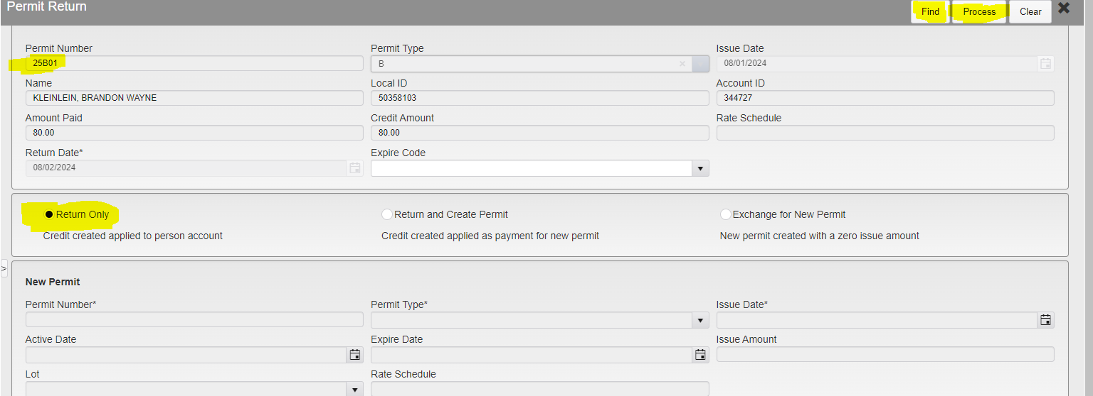Leave Expire Code blank
* **Process to Complete**

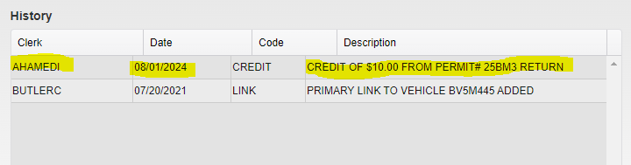**You can check if the return is successful by looking for the History box under the permit list tied with a person.**